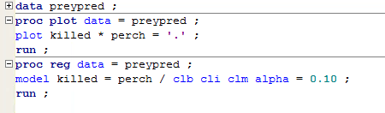**Prey attract predators**

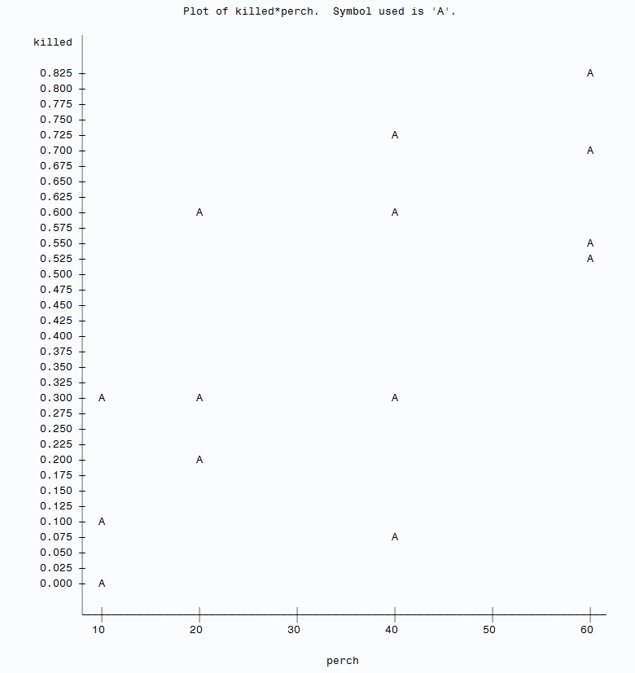

1. Scatterplot:

Since the explanatory variables “perch” are numbers of 10, 20, 40 and 60. The points would appears only on these vertical lines with x-axis to be 10, 20, 40 and 60.

2. The LSRL is $\hat{y}$ = 0.12049 + 0.00857x

(y is the proportion of perch killed and x is the number of perch)

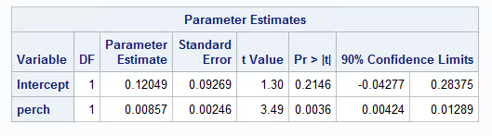

3. The slope of the regression line is 0.00857, which is positive. It tells us that when the number of perch (x) increases, the proportion of perch killed (y) will increase by 0.00857 unit.

Since the p-value = 0.0036 < 0.05, the association between the explanatory variable and the response variable is significant.

4. The 90% CI for slope is (0.00424, 0.01289)

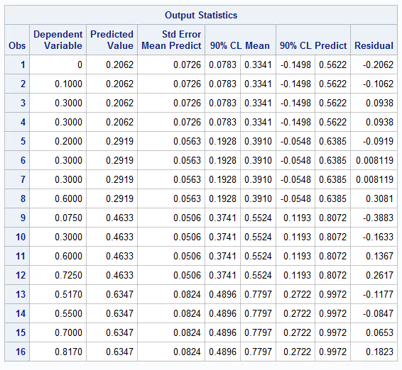5. The 90% CI for mean proportion is (0.3741, 0.5524)

6. The 90% PI for proportion of perch killed is (0.1193, 0.8072)

7. The PI is wider than CI. That’s because the standard error for a prediction is accounted for adding variability.